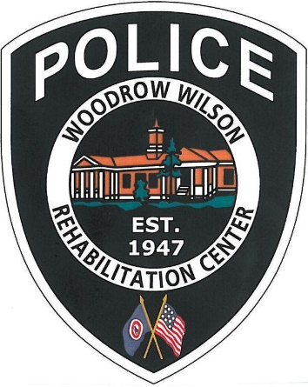
How are we doing???

We want to hear from you!!! We take the service provided by our department very seriously. If you have a concern, compliment, or complaint please let us know. You can contact us and obtain information in several ways.

- In person: Let our receptionist know that you wish to speak to a department member or a supervisor.
- By phone: Call 540-332-7317
- By email: send us a message at Policeinfo@wwrc.virginia.gov
- By mail: send us a letter to P.O Box 1500-W230
Fishersville VA 22939

Additional information can be obtained by reading our Public Suggestions and Input Pamphlet available here or visiting us on the web at www.wwrc.net/PoliceDepartment.
